# Template for a Digital Preservation Forward Plan using the DPC’s Rapid Assessment Model (DPC RAM)

This template has been provided as a starting point for a digital preservation forward plan designed to follow on from and respond to the results of a capability assessment using DPC RAM. It provides a suggested format to record the actions that are required to address gaps that have been highlighted and thus supports continuous improvement. The template uses the 11 sections of RAM as the framework for a forward plan. You are encouraged to adapt and edit the template as appropriate to meet the needs of your own organization. An example has been included in the first row of the plan for illustration only.

*Notes for use:*

* *Consider the timeframe for your forward plan and record this in the introduction to the document. Ensure your goals are realistic and achievable for the time frame specified.*
* *The 11 sections of RAM have been provided as a framework for this plan. You may not have actions relating to every section. Delete those that are not needed, or simply mark that no action is required at this time.*
* *Record your current RAM and target levels in each RAM section this will act as a helpful reference.*
* *The ‘Goal’ column may include an example taken directly from RAM or another goal that you would like to achieve to help you meet your target level. Do not be restricted by the examples included within RAM - remember there may be other goals that will help you move forward with a RAM section.*
* *You may wish to include multiple goals for one RAM section – add more rows to the table as appropriate.*
* *In the ‘Task’ column your goal can be broken down into multiple individual tasks or actions as appropriate – add more rows to the table as needed.*
* *Set a ‘Target date’ for each task. It may be easier to set dates for the higher priority tasks which should be done first and harder to set dates for tasks further down the line. If unsure about dates, enter just the year or ‘TBC’.*
* *Add any further details to the ‘Notes’ section as appropriate.*
* *The last column is included so that the progress of tasks can be logged as the forward plan is revisited over time. Leave this column blank where a task has not yet been started. Use terms such as ‘In Progress’, ‘Complete’, ‘Postponed’ to note progress. Your organization may have a preferred vocabulary for this.*
* *A table has been included at the start of the document to record the document history. This is particularly important if the document is updated over time with progress relating to specific goals. It is also recommended to save new versions of the document with a new file name as the plan is revisited over time.*
* *Remember to delete this front page before finalizing your forward plan.*

# <Organization name> Digital Preservation Forward Plan <month year>

Document history:

|  |  |  |  |
| --- | --- | --- | --- |
| **Version** | **Date** | **Authored/edited by** | **Notes** |
|  |  |  |  |
|  |  |  |  |
|  |  |  |  |

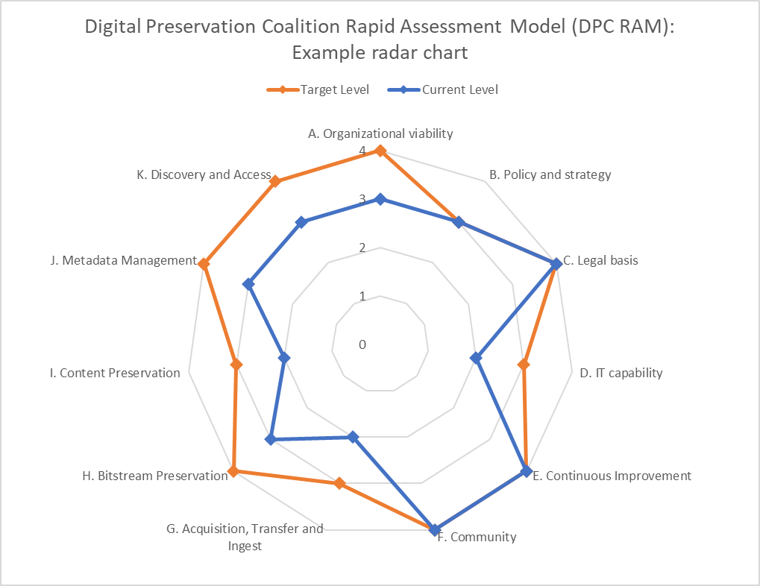

This document describes a forward plan for digital preservation activities based on the Digital Preservation Coalition’s Rapid Assessment Model (DPC RAM).[1]

An assessment using DPC RAM carried out in <date> highlighted gaps in capability that are illustrated in the radar chart (left) <replace with your own organization’s results>.

The 12 sections of RAM have been assigned scores from zero to four using the following scale (with both current level and target levels being measured):

1. Minimal awareness
2. Awareness
3. Basic
4. Managed
5. Optimized

Where gaps between current and target levels are highlighted, this roadmap sets out tasks and actions that are required to move digital preservation activities forward within <organization name>.

The plan defines activities to be carried out by <date>. It is anticipated that further RAM assessments and plans will be needed at this point to continue progressing digital preservation goals across the organization.

|  |  |  |  |  |  |
| --- | --- | --- | --- | --- | --- |
| **Section of DPC RAM (and current levels)** | **Goal** | **Task** | **Target date** | **Notes** | **Progress** |
| **A. Organizational viability**: Governance, organizational structure, staffing and resourcing of digital preservation activities.  **Current level** - [0-4]  **Target level** - [0-4] | *Staff have the skills they need to carry out digital preservation activities and access to relevant expertise where required.*  *(RAM level 3 example)* | *Carry out a skills audit using the DPC’s Competency Audit Toolkit* | *September 2024* | *Need to establish which staff to involve in this exercise and get buy in.* | *Complete* |
| *Establish plan to address any skills gaps highlighted* | *2025* | *Which staff have done Novice to Know-how online training? What other professional development opportunities exist?* | *In progress* |
|  |  |  |  |  |
| **B. Policy and strategy**: Policies, strategies, and procedures which govern the operation and management of the digital archive.  **Current level** - [0-4]  **Target level** - [0-4] |  |  |  |  |  |
|  |  |  |  |  |
| **C. Legal and ethical**: Management of legal, social and cultural rights and responsibilities, compliance with relevant regulation and adherence to codes of ethics related to acquiring, preserving and providing access to digital content.  **Current level** - [0-4]  **Target level** - [0-4] |  |  |  |  |  |
|  |  |  |  |  |
| **D. IT capability**: Information Technology capabilities for supporting digital preservation activities.  **Current level** - [0-4]  **Target level** - [0-4] |  |  |  |  |  |
|  |  |  |  |  |
| **E. Continuous Improvement**: Processes for the assessment of current digital preservation capabilities, the definition of goals and the monitoring of progress.  **Current level** - [0-4]  **Target level** - [0-4] |  |  |  |  |  |
|  |  |  |  |  |
| **F. Community**: Engagement with and contribution to the wider digital preservation community.  **Current level** - [0-4]  **Target level** - [0-4] |  |  |  |  |  |
|  |  |  |  |  |
| **G. Acquisition, Transfer and Ingest**: Processes to acquire or transfer content and ingest it into a digital archive.  **Current level** - [0-4]  **Target level** - [0-4] |  |  |  |  |  |
|  |  |  |  |  |
| **H. Bitstream Preservation**: Processes to ensure the storage and integrity of digital content to be preserved.  **Current level** - [0-4]  **Target level** - [0-4] |  |  |  |  |  |
|  |  |  |  |  |
| **I. Content Preservation**: Processes to preserve the meaning, usability and functionality of the digital content over time.  **Current level** - [0-4]  **Target level** - [0-4] |  |  |  |  |  |
|  |  |  |  |  |
| **J. Metadata Management**: Processes to create and maintain sufficient metadata to support preservation, discovery and use of preserved digital content.  **Current level** - [0-4]  **Target level** - [0-4] |  |  |  |  |  |
|  |  |  |  |  |
| **K. Discovery and Access**: Processes to enable discovery of digital content and provide access for users.  **Current level** - [0-4]  **Target level** - [0-4] |  |  |  |  |  |
|  |  |  |  |  |

1. https://www.dpconline.org/digipres/implement-digipres/dpc-ram